

**Politecnico di Milano**  
Dipartimento di Scienze e Tecnologie Aerospaziali  
Prova finale: Introduzione all’Analisi di Missioni Spaziali  
Docente: Massari Mauro

Elaborato n. C13

Autori:

|  |  |
| --- | --- |
| 10694997 | Pala Silvia |
| 10711624 | Turcu Alex Cristian |
| 10730510 | Vanelli Paolo |

Anno Accademico 2022-2023

Data di consegna: 00/00/00

# Table of contents

Table of contents 2

1. Introduction 3

2. Initial orbit characterization 4

2.1 Initial orbital parameters 4

2.2 Data interpretation 4

2.3 Graphical representation 4

3. Initial orbit characterization 5

3.1 Initial orbital parameters 5

3.2 Data interpretation 5

3.3 Graphical representation 5

4. Transfer trajectory definition and analysis 6

4.1.1 Standard Strategy 6

4.1.2 Possible alternative and decision explanations 6

4.1.3 Graphics 6

4.2 Alternative Strategy 1 7

4.3 Alternative Strategy 2 7

4.4 Alternative Strategy 3 7

5. Conclusions 7

6. Appendix 7

# Introduction

The project aims to study, optimize and choose various orbital transfer strategies, having as initial data a point on the initial orbit, which position and velocity vectors are given, and a point on the final orbit, which is defined by its orbital parameters.

First it will be analysed a strategy based on a set of standard manoeuvres.

Several other alternative strategies have been examined to try to optimize the two most significant parameters in their distinction: the manoeuvring cost (the total speed gap required to complete all the orbital changes) and the operating time (from the start point to the final point).

All calculations and plots are made using MATLAB software.

# Initial orbit characterization

## Initial orbital parameters

The assigned starting position and velocity vectors are the following:

It is possible to calculate the orbital parameters assigned to this specific couple of vectors:

|  |  |  |  |  |  |
| --- | --- | --- | --- | --- | --- |
|  |  |  |  |  |  |
| 8369.7448 | 0.1097 | 0.8487 | 1.5339 | 1.1849 | 1.8025 |

## Data interpretation

The starting geocentric orbit is elliptical, with an eccentricity value between 0 and 1 and a specific energy of:

It belongs to Medium Earth Orbit (MEO) category, as its apogee and its perigee are inside the range of 8000 – 42000 km:

According to the given value, it is nor a polar nor a geo-synchronous orbit and has a period of:

## Graphical representation

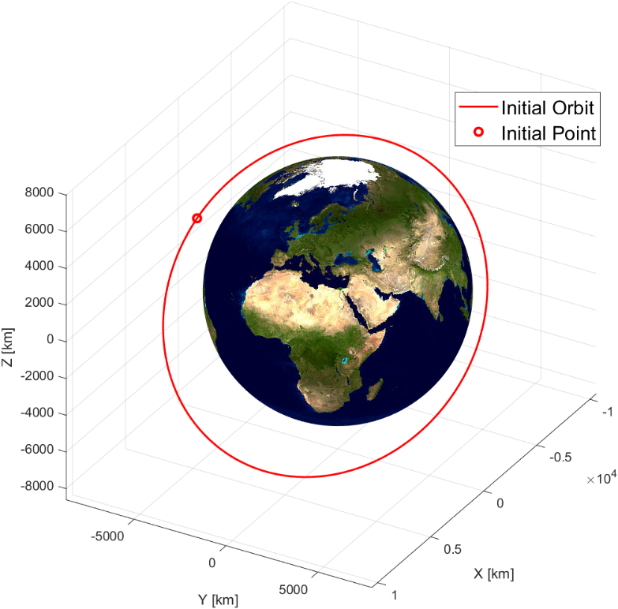

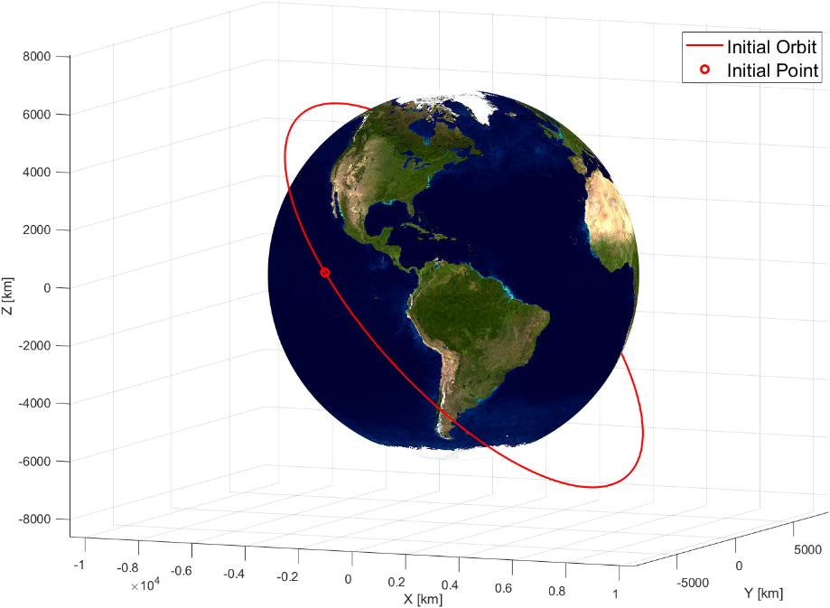

# Initial orbit characterization

## Initial orbital parameters

The goal orbit, that is geocentric just like the starting one, is defined by its orbital parameters:

|  |  |  |  |  |  |
| --- | --- | --- | --- | --- | --- |
|  |  |  |  |  |  |
| 10860 | 0.2332 | 0.5284 | 3.0230 | 0.4299 | 0.3316 |

The final position and velocity are calculated from these parameters:

## 3.2 Data interpretation

The final geocentric orbit is elliptical, with an eccentricity value between 0 and 1 and a specific energy of:

It belongs to Medium Earth Orbit (MEO) category, as its apogee and its perigee are inside the range of 8000 – 42000 km:

According to the given value, it is nor a polar nor a geo-synchronous orbit and has a period of:

## 3.3 Graphical representation

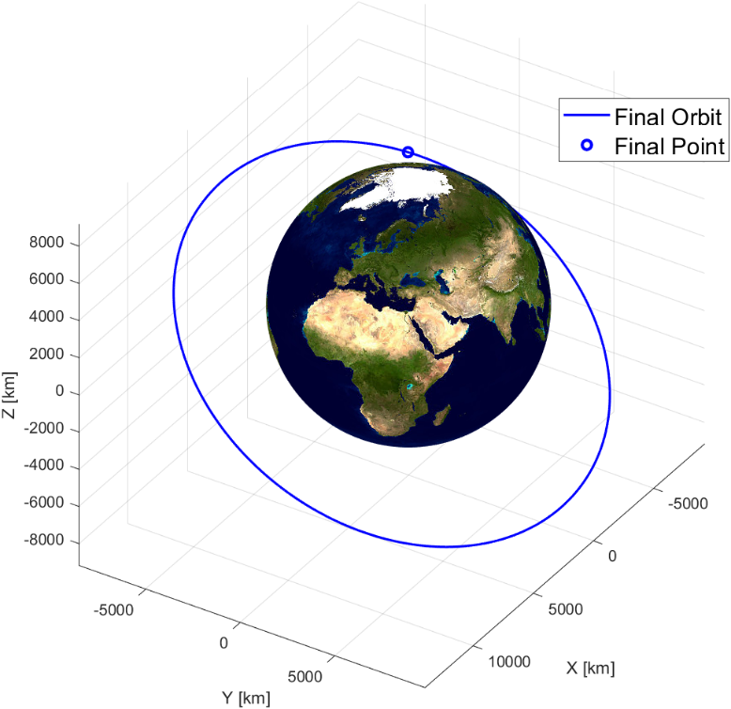

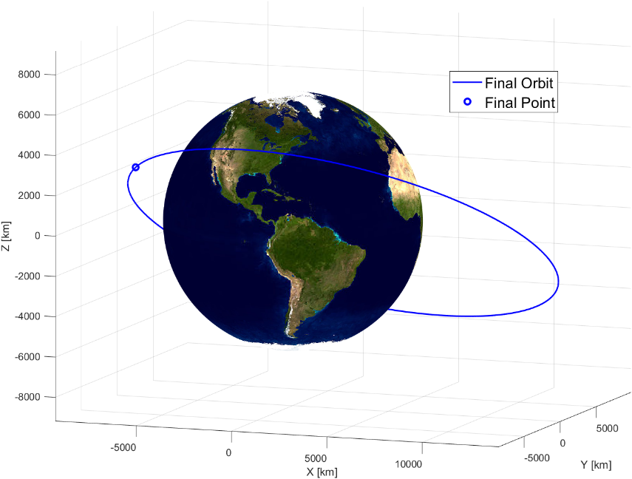

# Transfer trajectory definition and analysis

## 4.1.1 Standard Strategy

It is possible to reach the final assigned point, located on the final orbit, from the initial point on the initial orbit, through a standard strategy using a specific permutation of the three known manoeuvres between orbits. The chosen standard strategy is composed of, in sequence, a bitangent transfer perigee to apogee, a change of the orbital plane and a change of the pericentre anomaly. Each manoeuvre changes a specific set of orbital parameters.

To perform the first manoeuvre, it is needed to reach the first orbit’s pericentre, due to the nature of the bitangent chosen manoeuvre, where the first impulse is made, moving the satellite on a new orbit, that differs from the previous orbit with a new major semiaxis and a new eccentricity.

Once reached the apogee of the second orbit, through another impulse, the satellite is transferred to a third orbit with the same major semiaxis and same eccentricity as the final assigned orbit.

Given the finale inclination, it is needed to change the inclination of the orbit in a specific point. Through this manoeuvre the final inclination and final RAAN can be achieved, however it also changes the pericentre anomaly, that needs to be adjusted with the last impulse.

The final point is reached after a short travel on the final orbit.

## 4.1.2 Possible alternative and decision explanations

## 4.1.3 Graphics

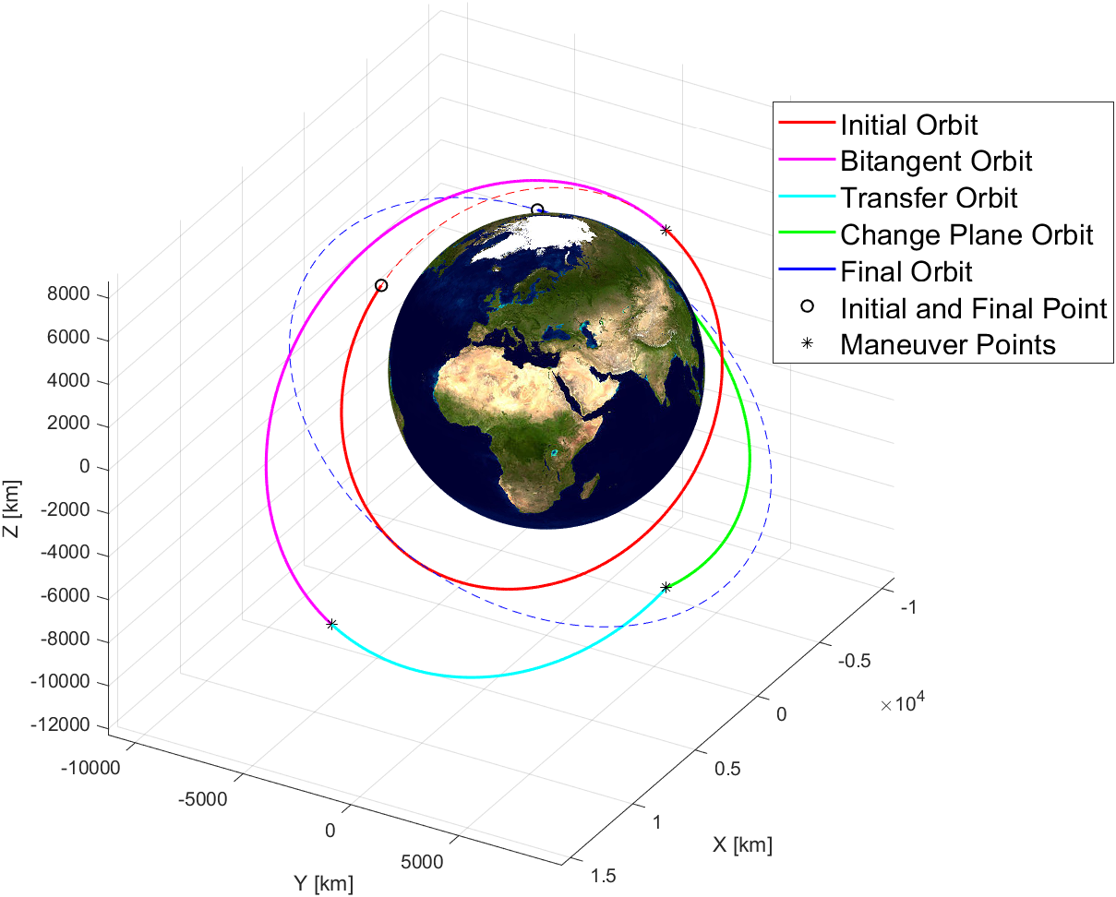

## 4.2 Alternative Strategy 1

## 4.3 Alternative Strategy 2

## 4.4 Alternative Strategy 3

# 5. Conclusions

# 6. Appendix